**Machine Learning Models Deployment with IBM Cloud Watson Studio Problem Statement:**

Become a wizard of predictive analytics with IBM Cloud Watson Studio. Train machine learning models to predict outcomes in real time. Deploy the models as web services and integrate them into your applications. Unlock the magic of data-driven insights and make informed decisions like never before!

# Project Title: Machine Learning Model Deployment for Student Dropout Analysis with IBM Cloud Watson Studio

**Problem Definition:**

Student dropout rates in educational institutions have become a significant concern. Institutions invest substantial resources in nurturing students' potential, and when students drop out, it not only affects their futures but also leads to the underutilization of educational resources. The problem we aim to address is:

**Approach Used:**

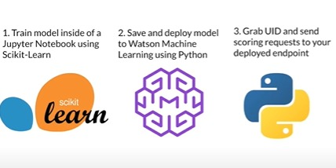

**Step 1 - Setting Up IBM Cloud and IBM Watson Machine Learning:**

* Authenticate and set up an IBM Cloud account.
* Navigate to the IBM Watson Machine Learning catalog.
* Select a third-party service or app to function with Watson Machine Learning.
* Use an existing warehouse and the IBM Watson Machine Learning catalog interface.
* Suggest selecting a free plan and setting up Watson Studio.
* Set up a new deployment space, associate it with the machine learning service, and save and deploy the model.

**Step 2 - Deploying with Python:**

* Set up an API key and credentials for different regions
* Create a Python machine learning client using the IBM Watson Machine Learning API key and the api_client class.
* List deployment spaces and set a default deployment space.
* Explain how to save and deploy the model, specifying the model name, deployment name, and best model.

**Step 3 - Model Deployment with Metadata:**

* Output the model and save it to a machine learning environment.
* Specify model metadata using a dictionary and pass it through deployment.
* Save the model in the Watson Machine Learning repository.
* Pass keyword parameters, including model name, type, software specification UID, training data, and training target.
* Record the model ID for automation purposes.

**Step 4 - Deploying a Model:**

* Obtain the model's UID saved in a deployment space.
* Specify deployment underprop and use the command wml_client.deployment.create to deploy the saved model.
* Set the artifact_uid keyword parameter to the model's ID.
* Pass deployment properties in quantum format.

**Step 5 - Scoring the Deployed Model:**

* Explain how to score the deployed model.
* Grab the deployment UID and send data from a pandas data frame to it.
* Specify wml_client.deployments.get_uid and payload to make the API request.
* The payload contains input data in the form of an array representing the columns and values of the data frame.

**Project Progression:**

**PHASE 3 - PROJECT DEVELOPMENT PART-1**

* Uploading the Dataset
* Dataset cleansing
* Exploratory data analysis

**PROJECT DEVELOPMENT PART-2**

* Model selection

**FINAL PHASE OF THE PROJECT**

* Deployment of the model in IBM Cloud Watson Studio

**LINK TO THE DATASET**

<https://docs.google.com/spreadsheets/d/1yg9IjaccCUlX347lQQGEYqVblfF-Mq8ITA4U_HbfGv4/edit?usp=sharing>

**About the Dataset:**

This dataset offers a comprehensive perspective on students enrolled in diverse undergraduate programs provided by a higher education institution. It encompasses a wide array of information, including demographic details, socioeconomic factors, and academic performance metrics. The dataset is instrumental in conducting an analysis to identify potential predictors of student attrition and academic achievement.

The dataset is divided into multiple separate databases, each containing pertinent information recorded at the time of enrollment. This information includes details such as the application mode, marital status, chosen courses, and more. Furthermore, the dataset enables the assessment of students' overall performance at the end of each semester, considering factors like the curricular units they completed, enrolled in, evaluated, or had approved, along with the corresponding grades.

In addition to academic data, the dataset also provides economic indicators, such as the unemployment rate, inflation rate, and regional GDP. These economic factors contribute to a holistic understanding of how they might influence student attrition rates and academic outcomes.

This dataset is a valuable analytical tool, offering insights into the factors that motivate students to persist in their studies or discontinue their educational pursuits across a diverse range of academic disciplines, including agronomy, design, education, nursing, journalism, management, social services, and technology.

**Column:**

* Marital status: The marital status of the student. (Categorical)
* Application mode: The method of application used by the student. (Categorical)
* Application order: The order in which the student applied. (Numerical)
* Course: The course taken by the student. (Categorical)
* Daytime/evening attendance: Whether the student attends classes during the day or in the evening. (Categorical)
* Previous qualification: The qualification obtained by the student before enrolling in higher education. (Categorical)
* Nationality: The nationality of the student. (Categorical)
* Mother's qualification: The qualification of the student's mother. (Categorical)
* Father's qualification: The qualification of the student's father. (Categorical)
* Mother's occupation: The occupation of the student's mother. (Categorical)
* Father's occupation: The occupation of the student's father. (Categorical)
* Displaced: Whether the student is a displaced person. (Categorical)
* Educational special needs: Whether the student has any special educational needs. (Categorical)
* Debtor: Whether the student is a debtor. (Categorical)
* Tuition fees up to date: Whether the student's tuition fees are up to date. (Categorical)
* Gender: The gender of the student. (Categorical)
* Scholarship holder: Whether the student is a scholarship holder. (Categorical)
* Age at enrollment: The age of the student at the time of enrollment. (Numerical)
* International: Whether the student is an international student. (Categorical)
* Curricular units 1st sem (credited): The number of curricular units credited by the student in the first semester. (Numerical)
* Curricular units 1st sem (enrolled): The number of curricular units enrolled by the student in the first semester. (Numerical)
* Curricular units 1st sem (evaluations): The number of curricular units evaluated by the student in the first semester. (Numerical)
* Curricular units 1st sem (approved): The number of curricular units approved by the student in the first semester. (Numerical)

**Code:**

**Importing Libraries:**

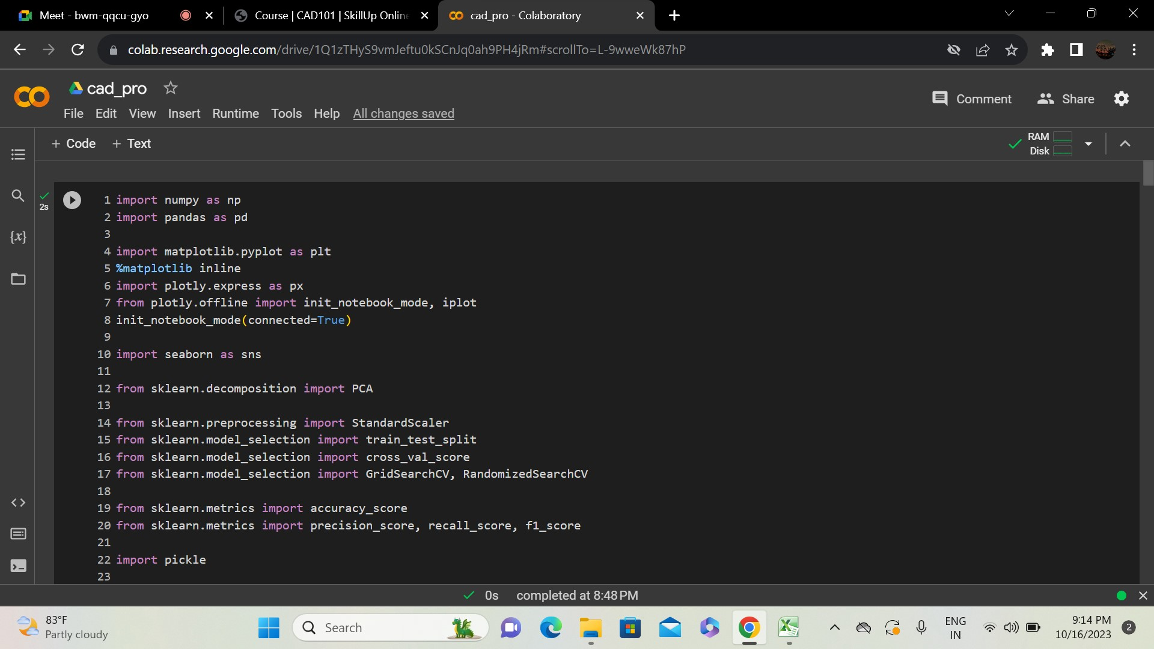

**Understanding the datasets:**

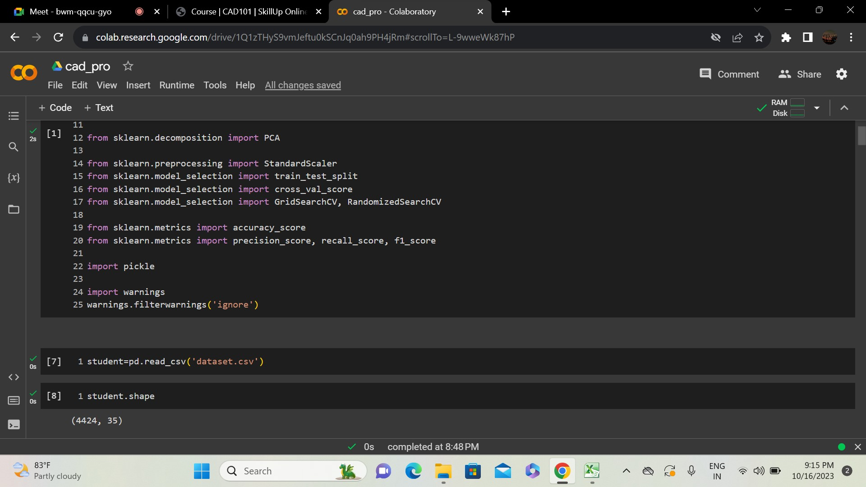



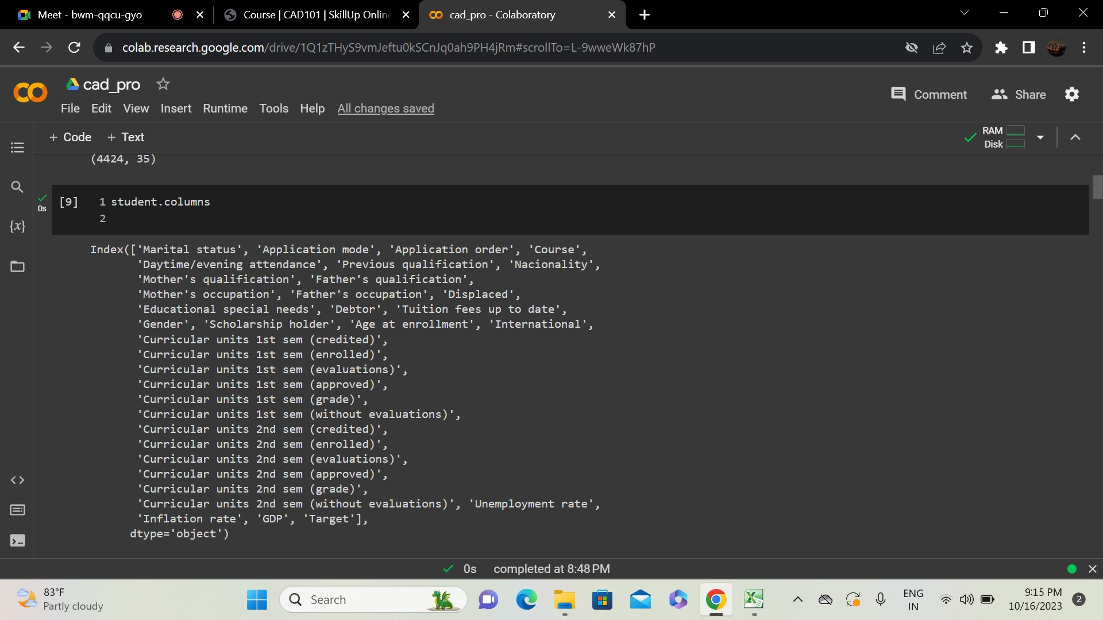

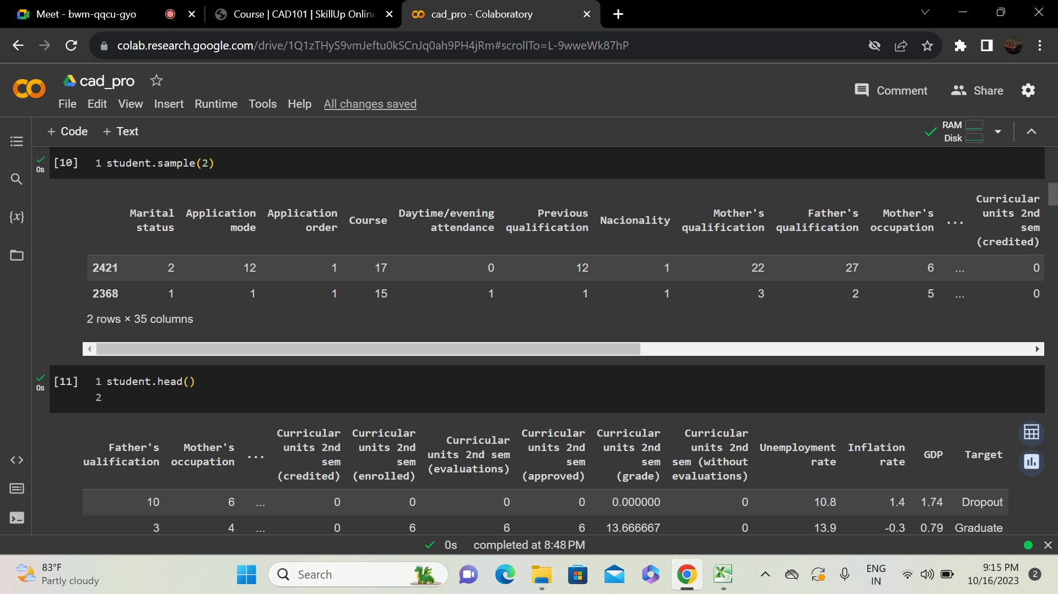

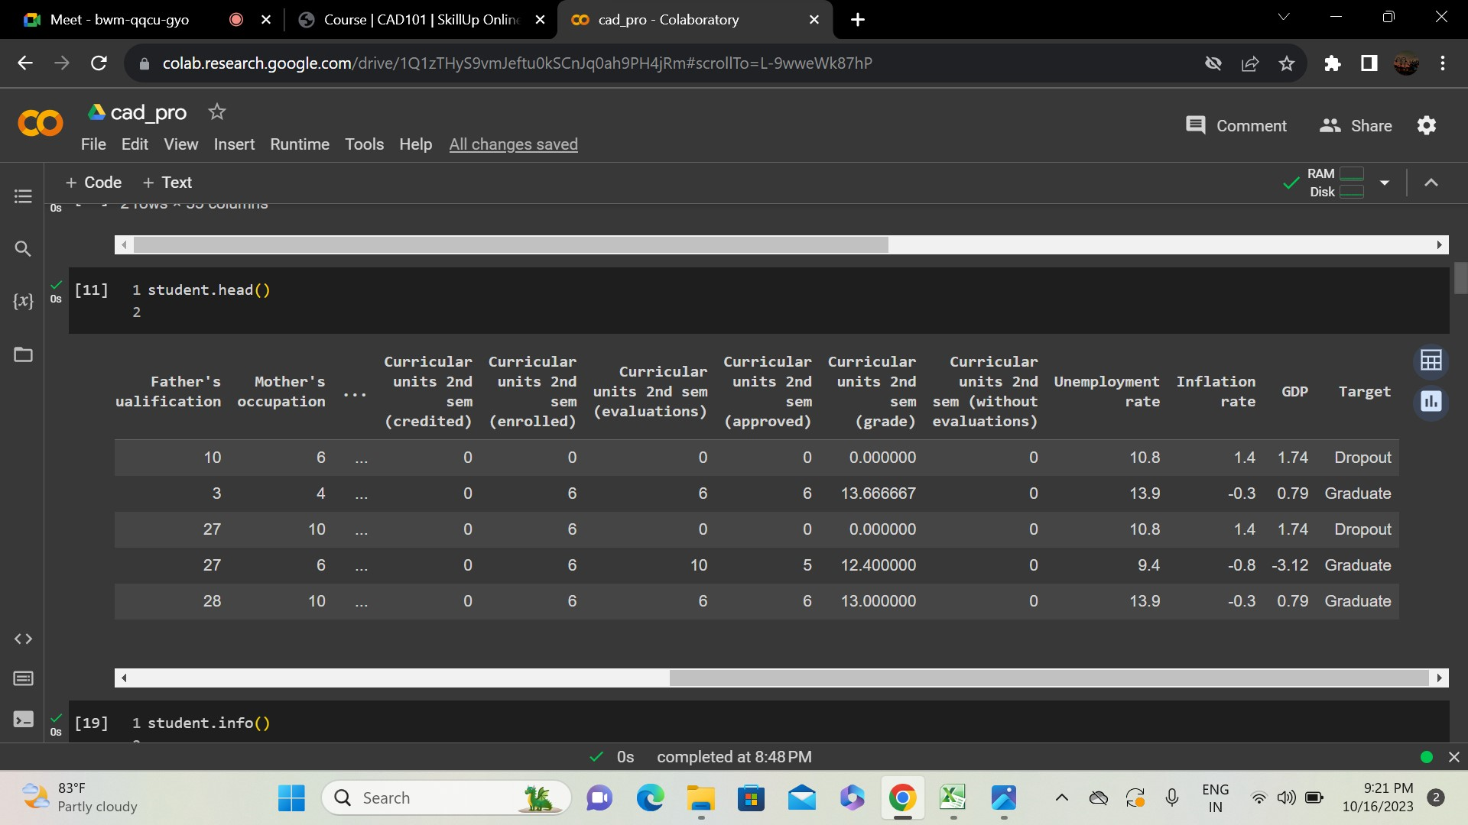

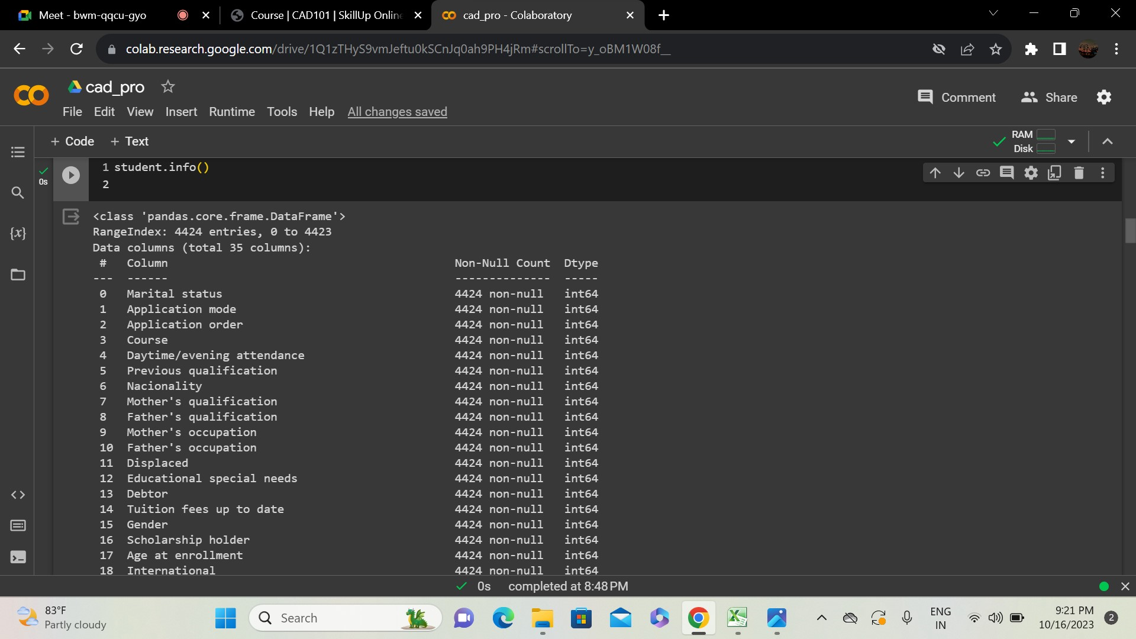

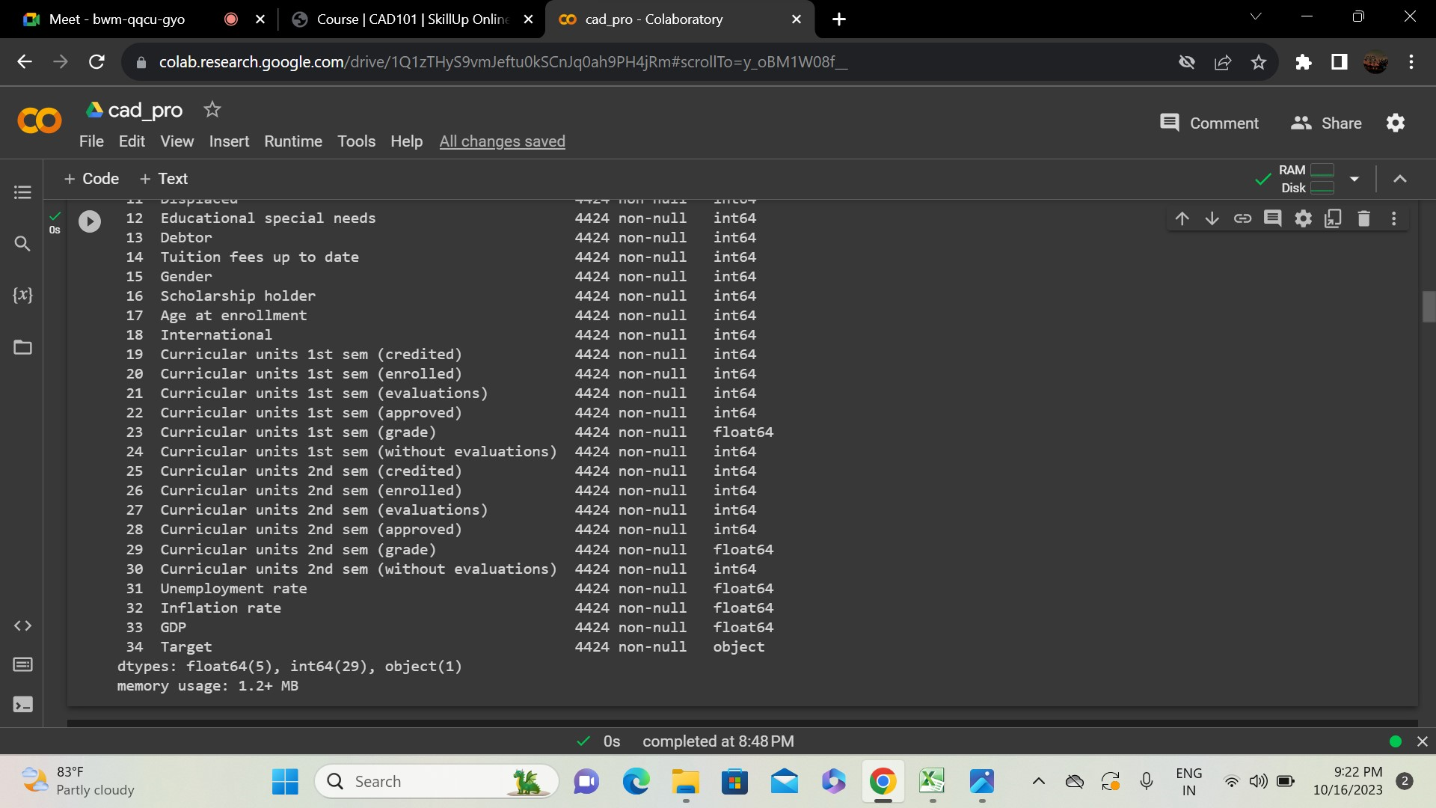

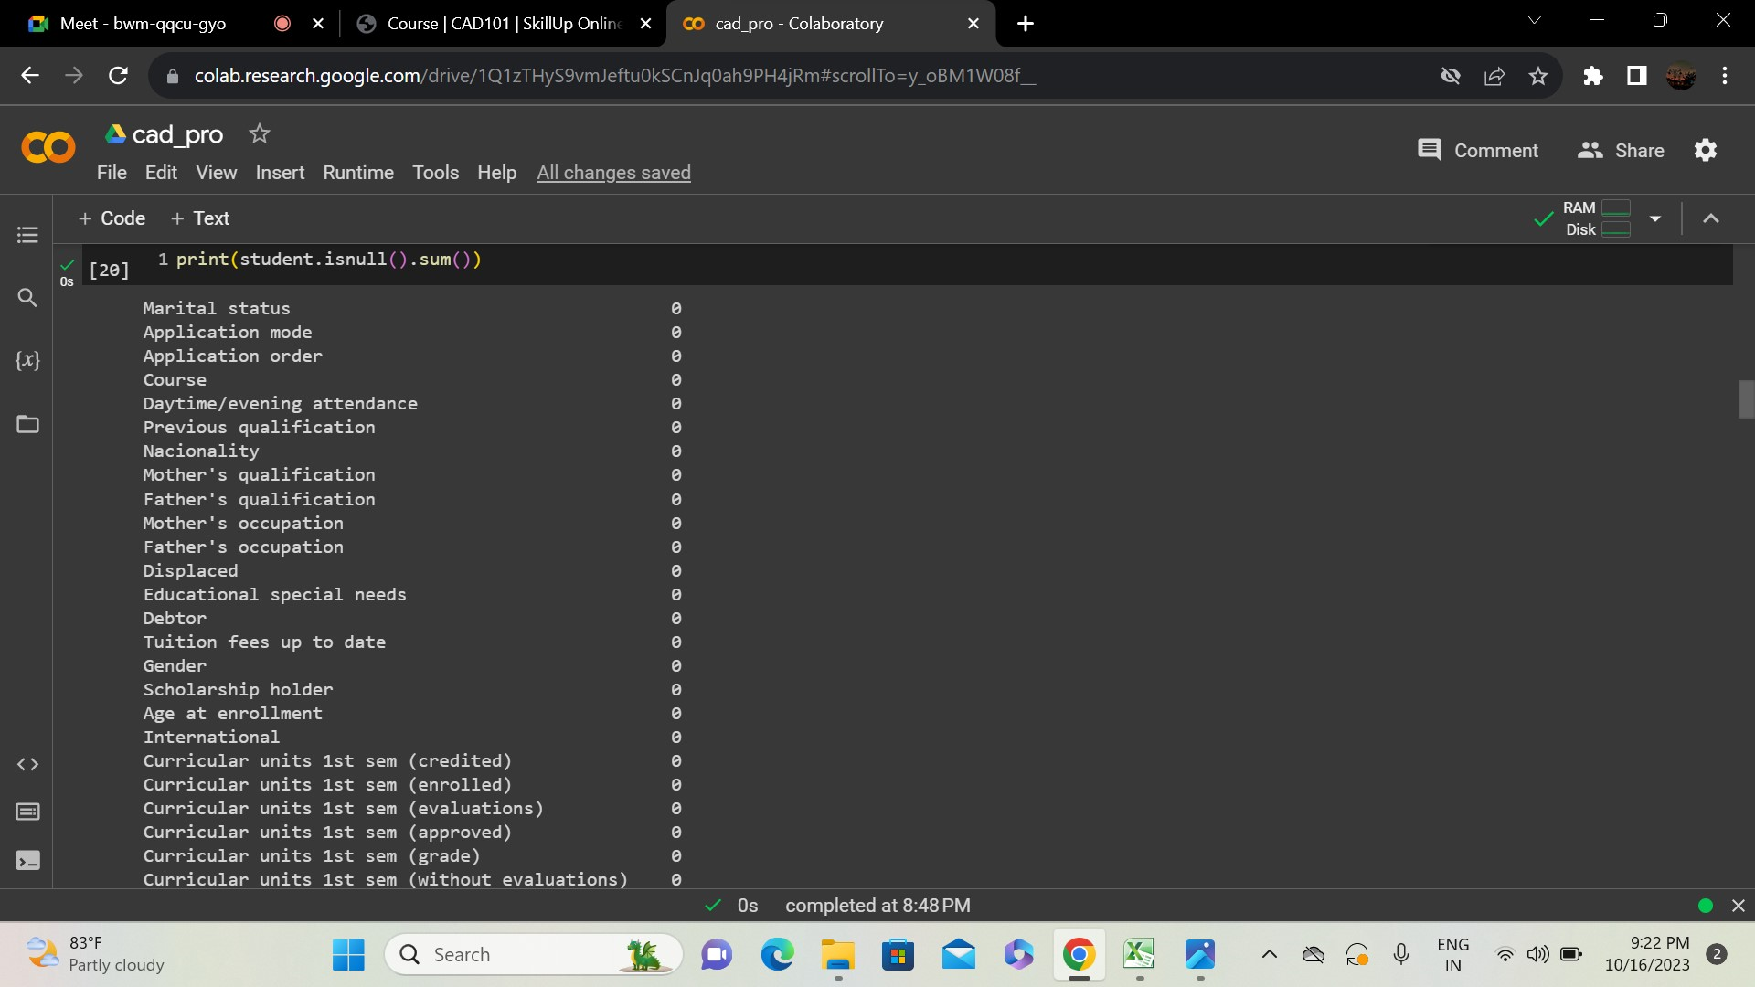

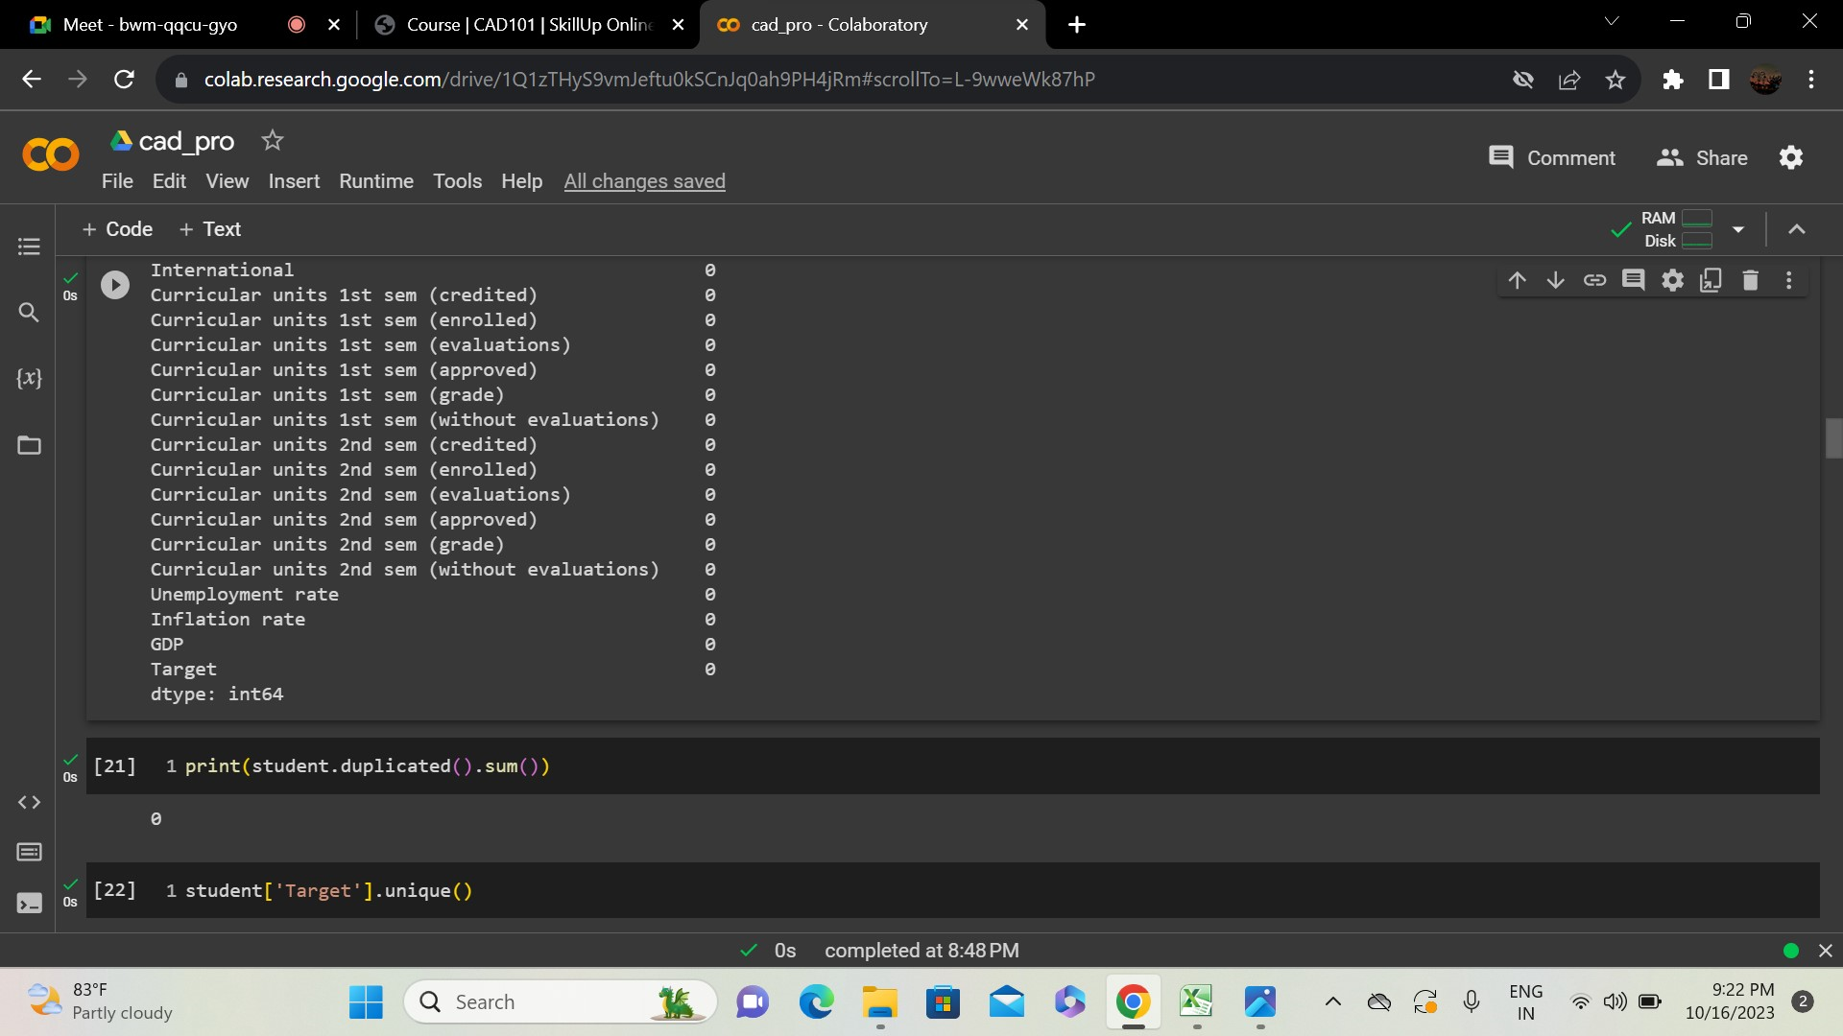

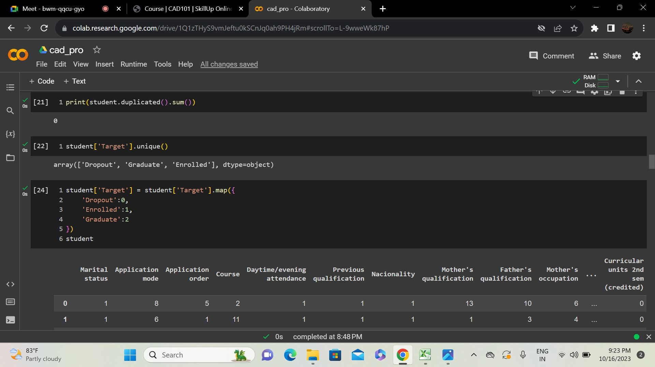

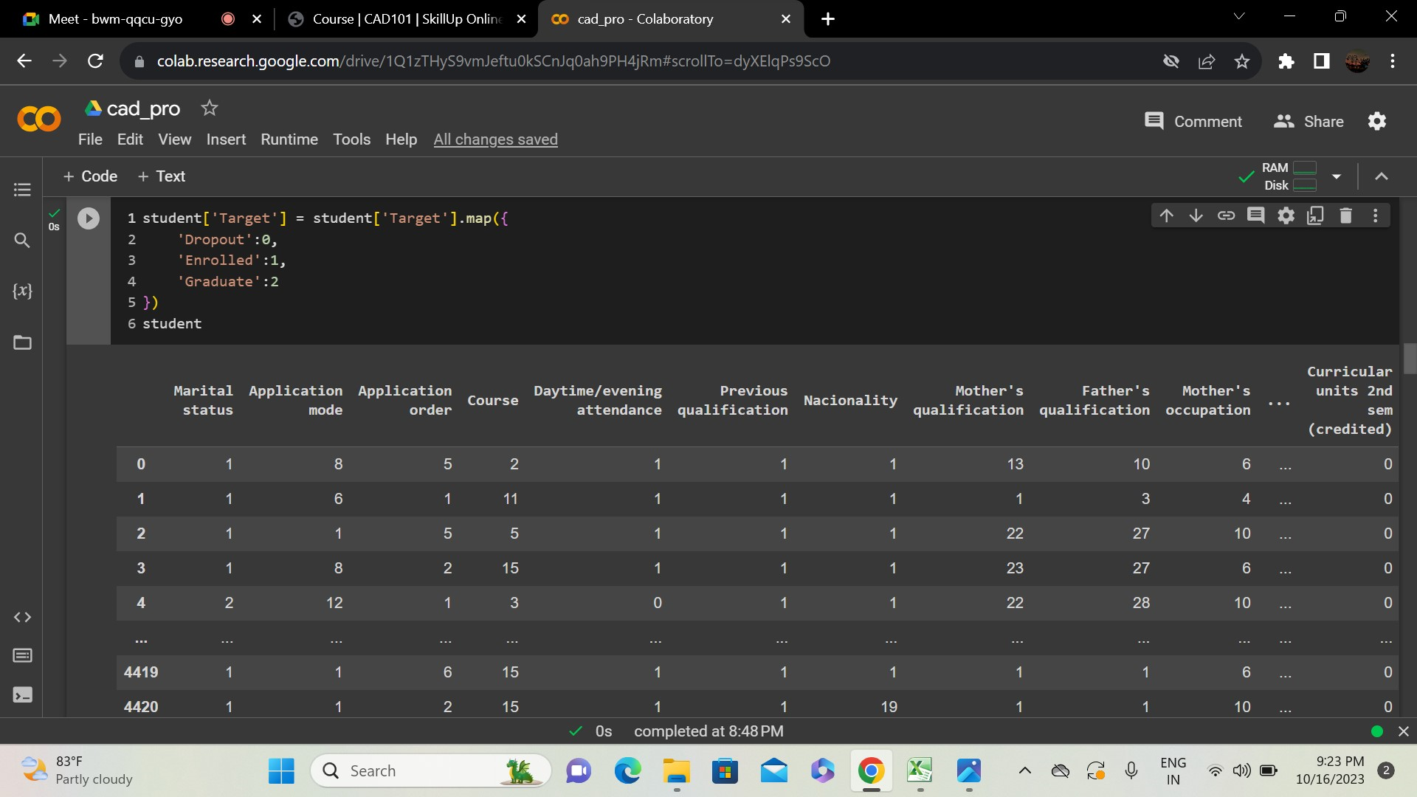

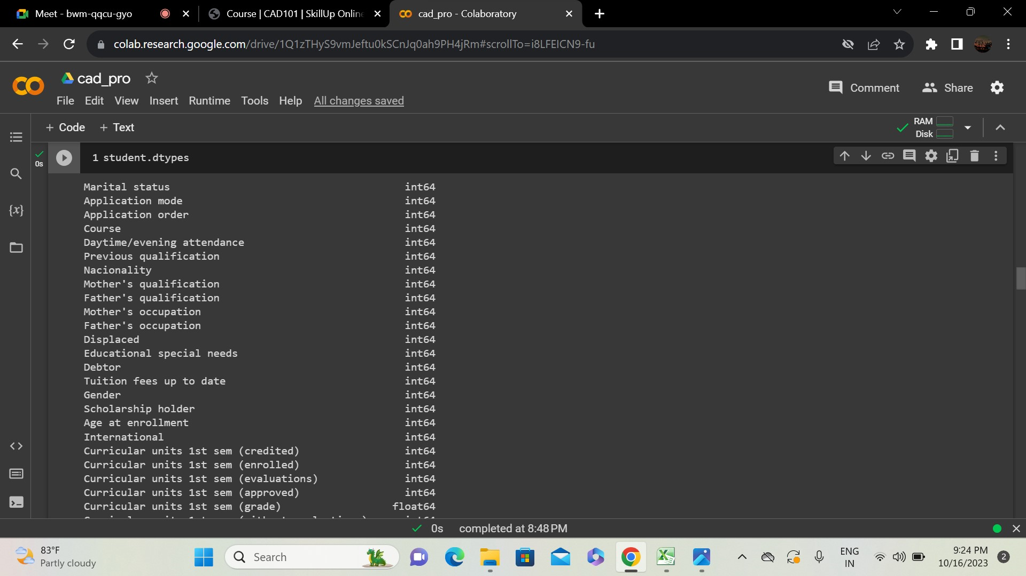

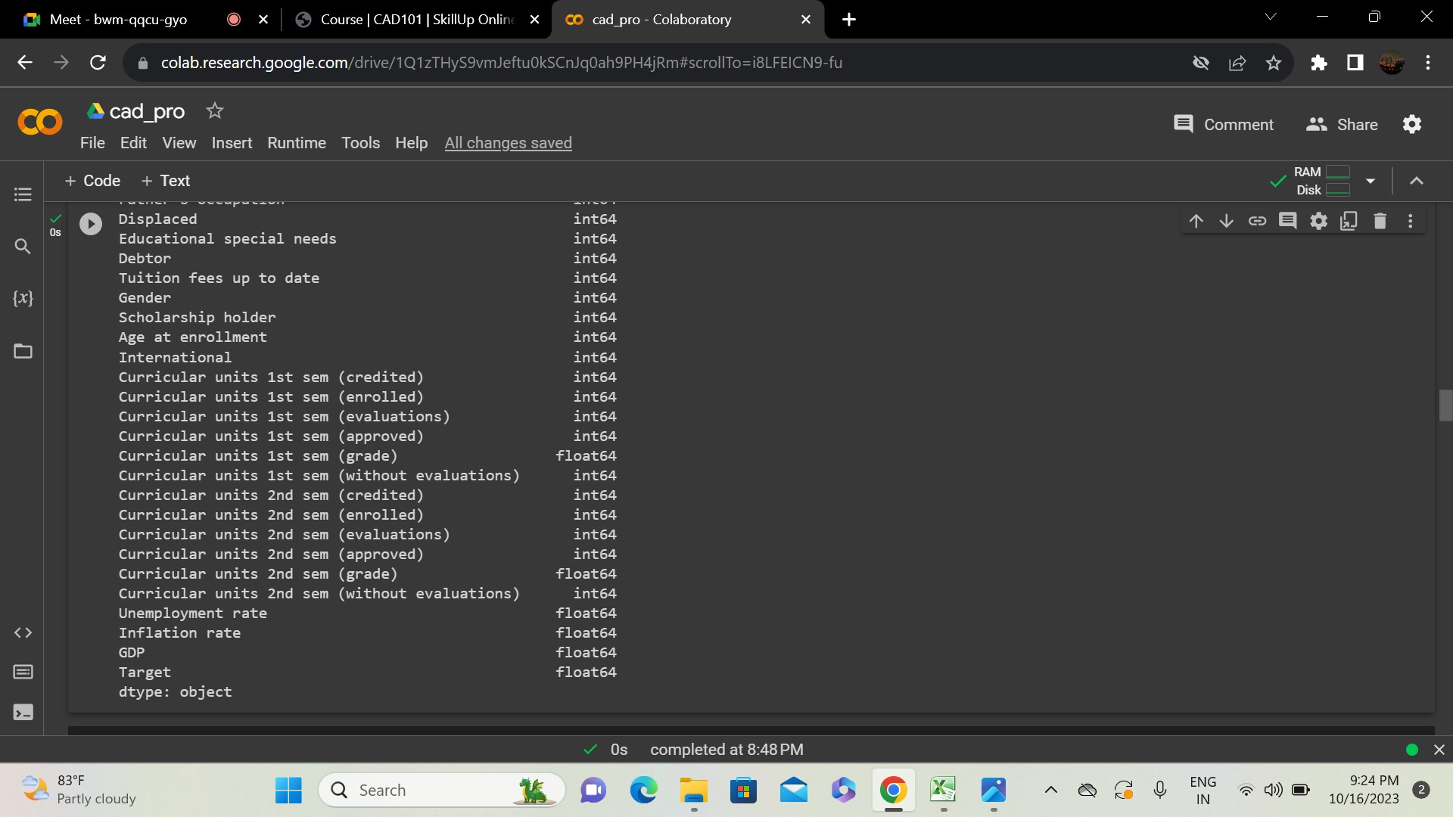

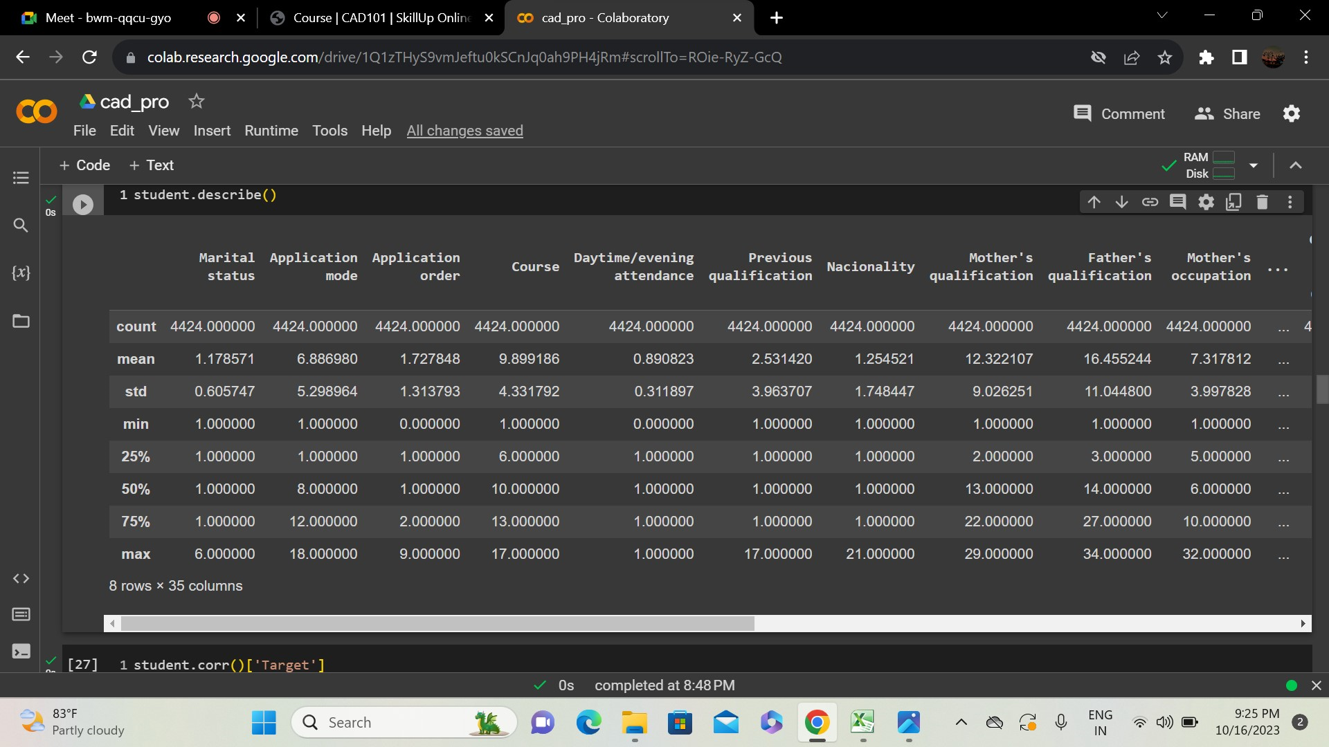

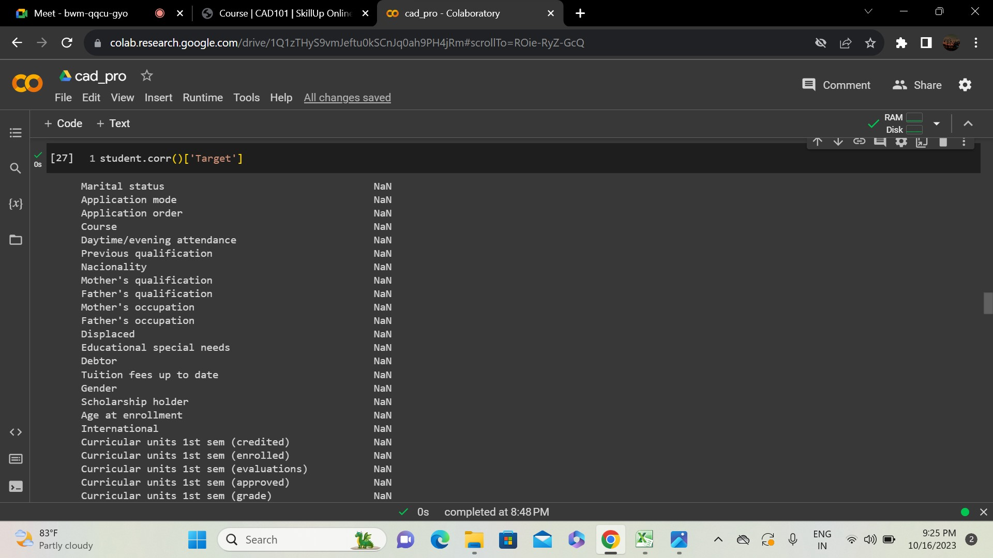

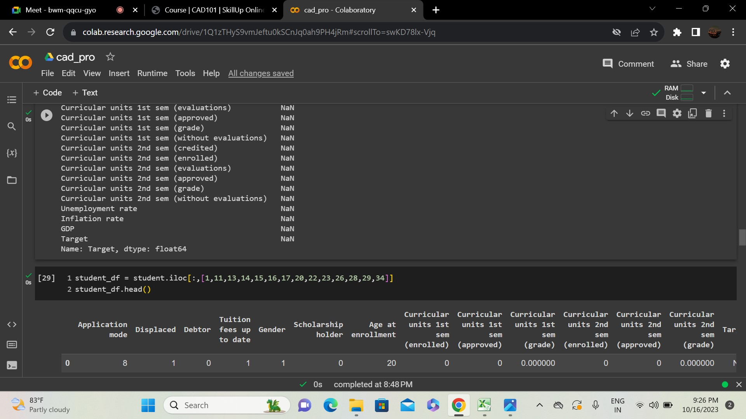

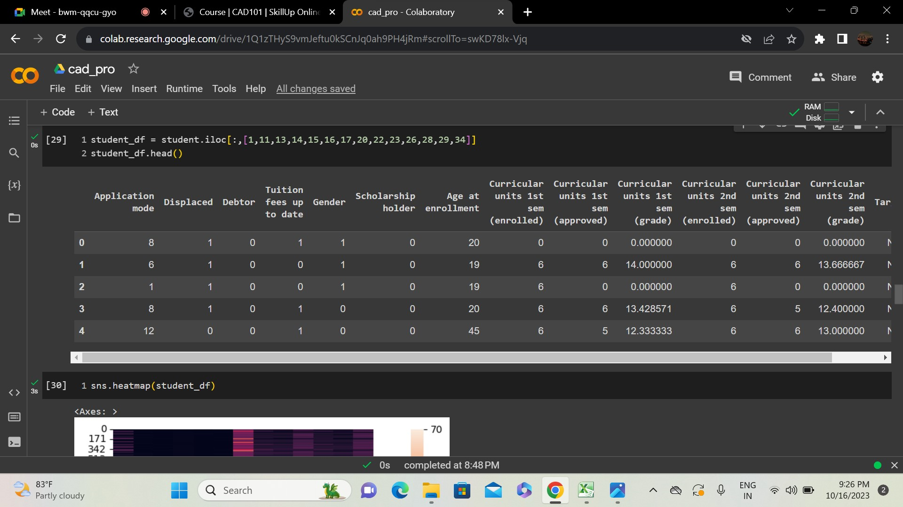

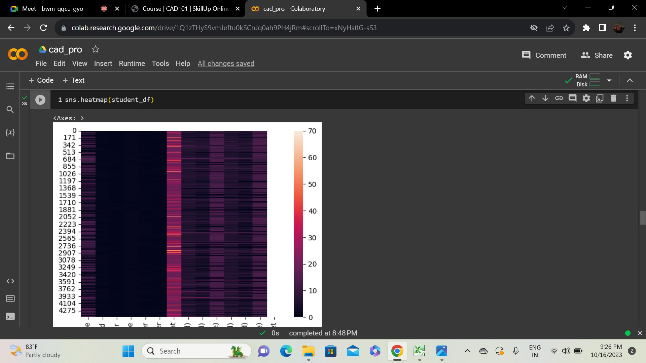

**Exploratory Data Analysis:**

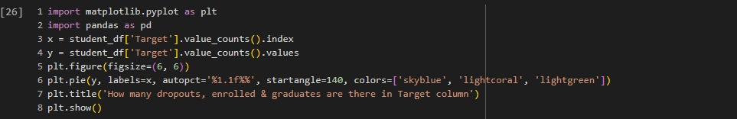

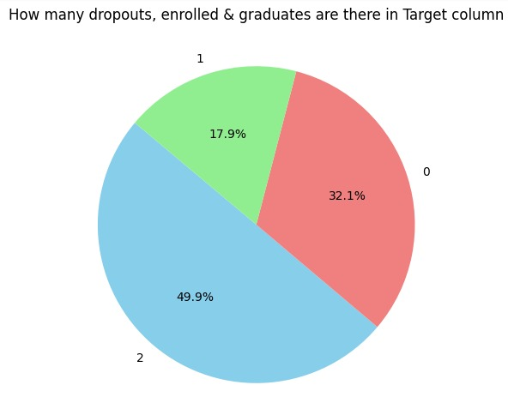

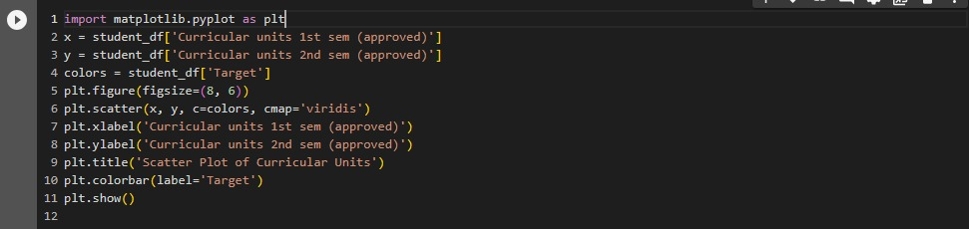

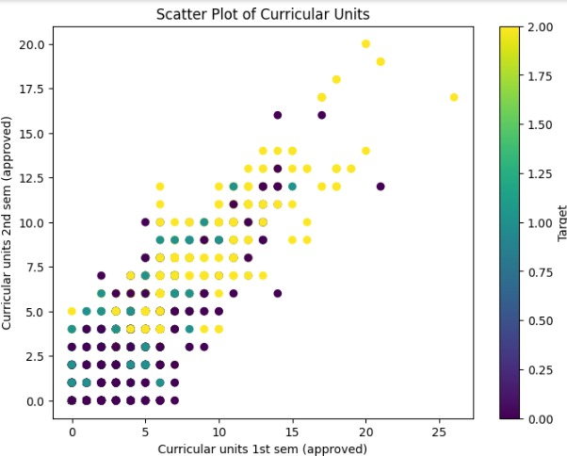

**LINK TO THE GOOGLE COLAB NOTEBOOK:**

<https://colab.research.google.com/drive/1Q1zTHyS9vmJeftu0kSCnJq0ah9PH4jRm?usp=sharing>

**CONCLUSION:**

In conclusion, this project harnesses the power of machine learning and IBM Cloud to tackle the issue of student dropout in educational institutions. By deploying predictive models, we enable these institutions to make informed decisions and take proactive steps to improve student retention rates, ultimately ensuring that students have a better chance at a successful academic journey. This work underscores the importance of data-driven insights in addressing real-world challenges in the educational sector.